Screen Captures

Florencia Chomski & Ahmad Jamal

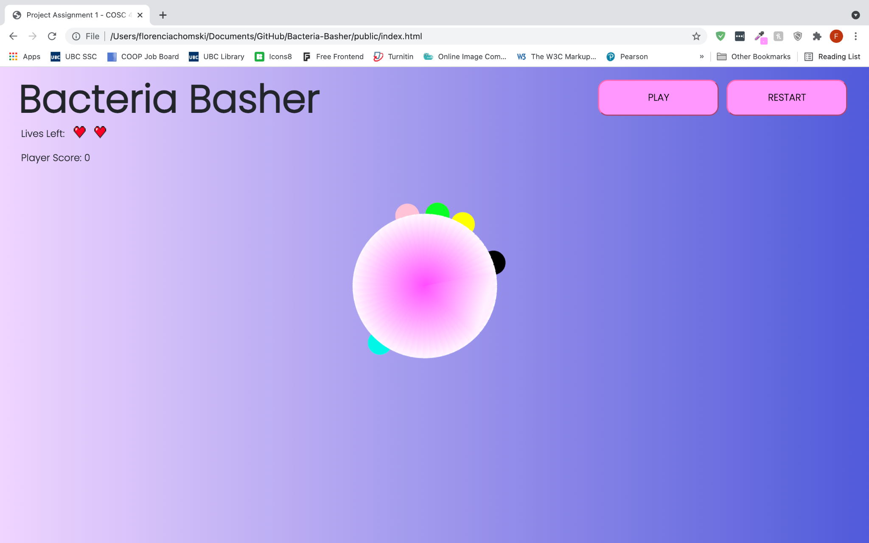

*The playing field starts as a circular disk centered at the origin, with a view from above (requirements [1] and [2]). Bacteria of several colours grow on the circumference of the disk and grow outwards (requirement [3 & 7]).*

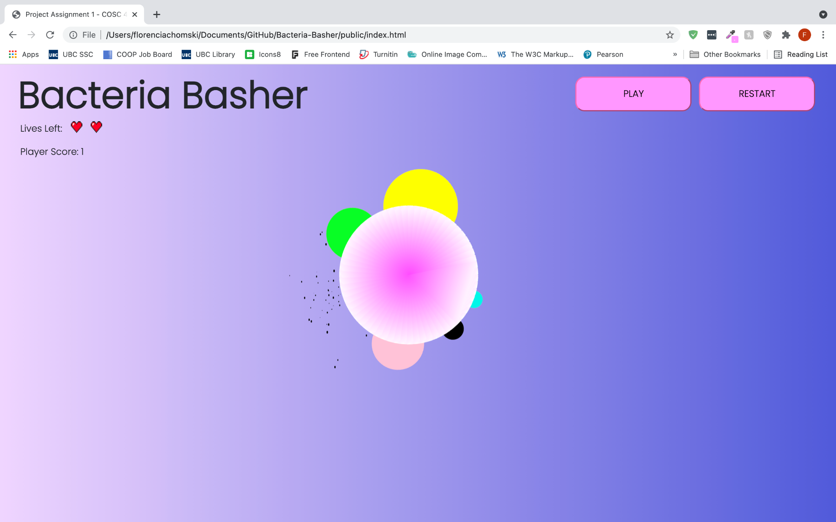

*The player removes bacteria by clicking on the bacterial growth (requirement [4]). Clicking on the bacteria immediately removes the growth of that bacteria (requirement [5]). The game produces up to 5 bacteria with different colours, all shown above; green, yellow, pink, black, and blue (requirement [6]).*

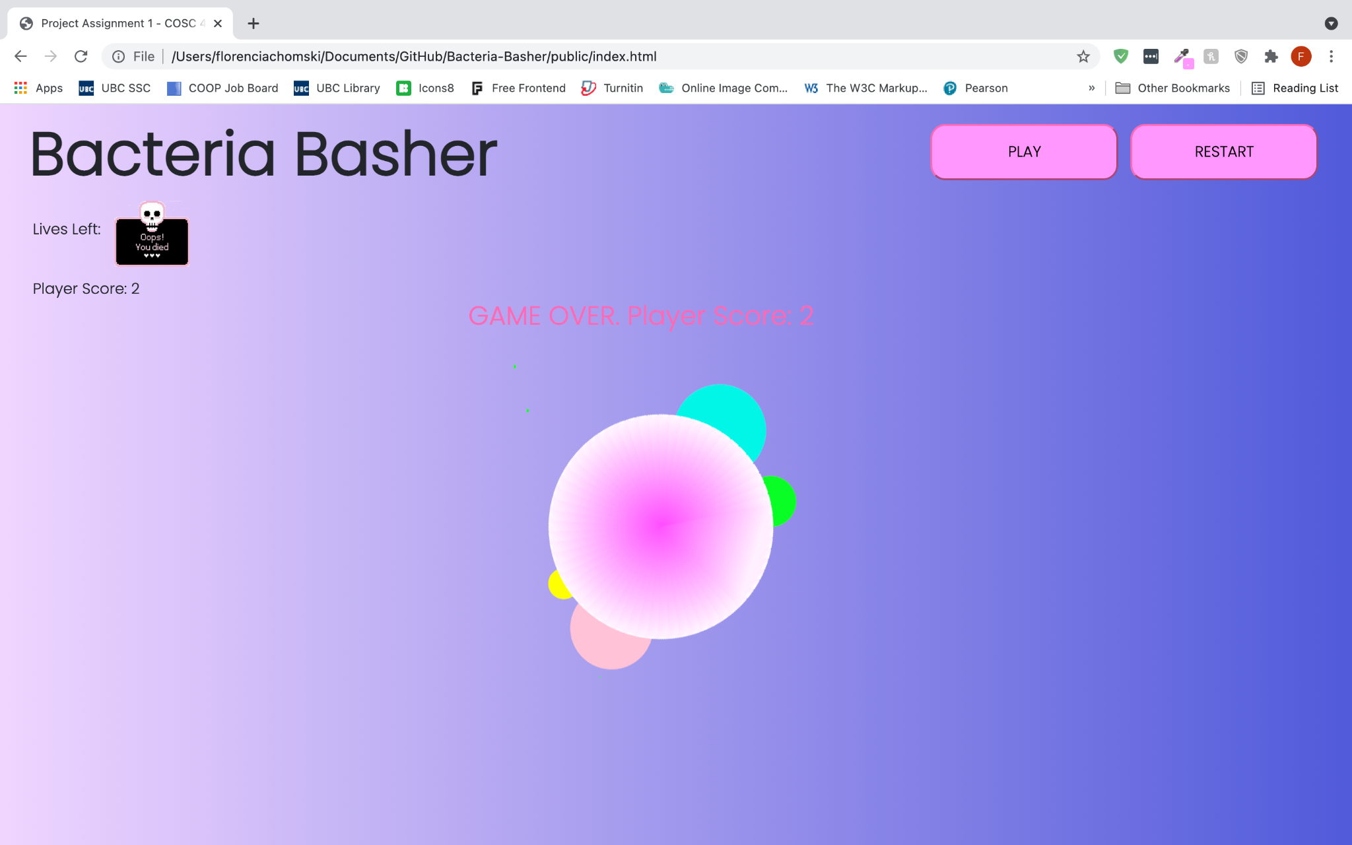

*When two bacteria of different colours have reached a radius of 0.35 or greater, the game is over (requirement [8]). Some text that reads ‘Game Over’ as well as the current player score is displayed.*

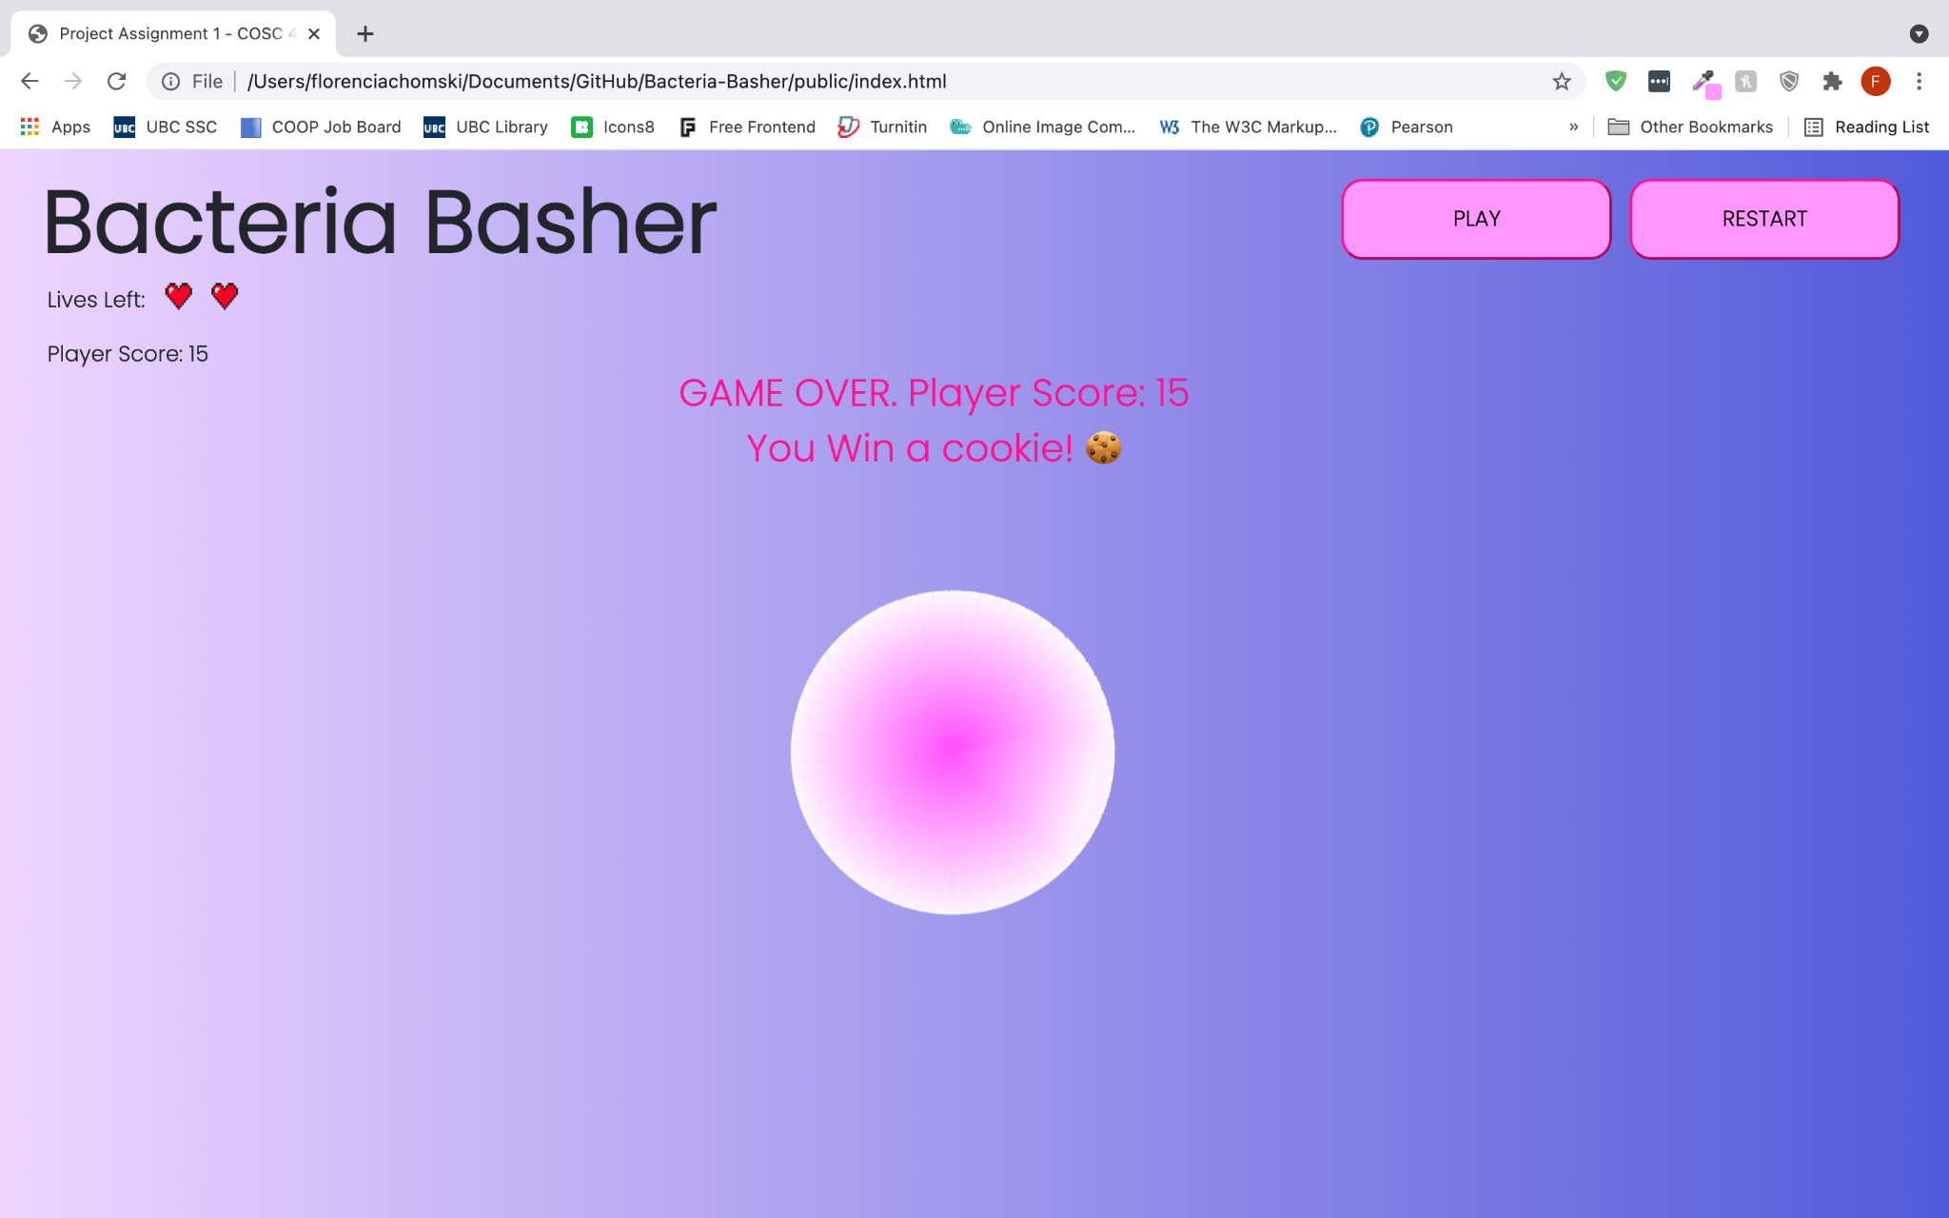

*The player wins if they reach a score of 15 before two bacteria of different colours reach the threshold of a radius size 0.35 (requirement [9]).*

|  |  |
| --- | --- |

*When two bacteria cultures collide, the first one to appear on the circumference dominates and consumes the latter generated bacteria as shown above with the yellow and pink bacteria. Yellow was first to be generated and thus consumes the pink bacteria on collision.*

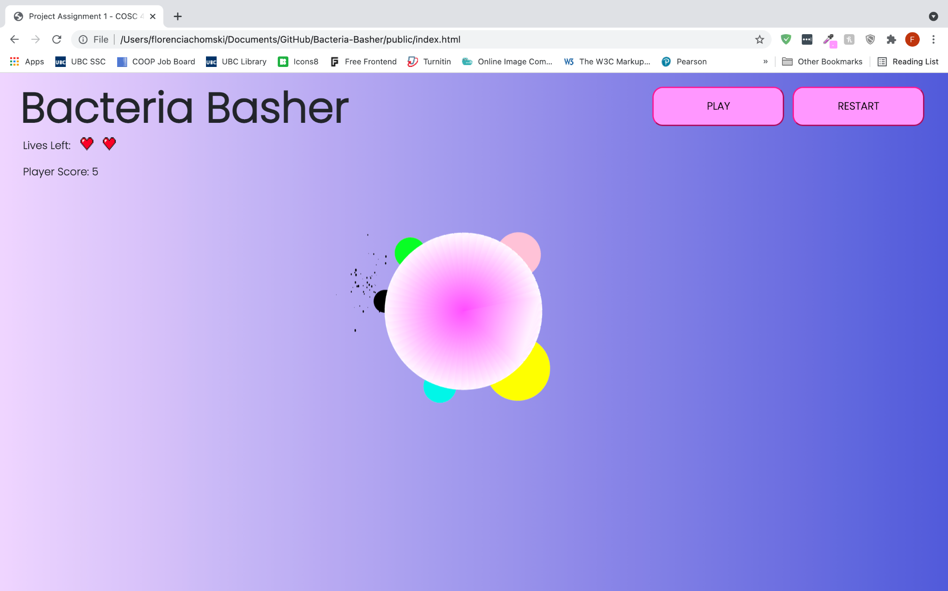

*When a bacterial culture is hit, a small explosion occurs from the point that was clicked.*

Additional Features

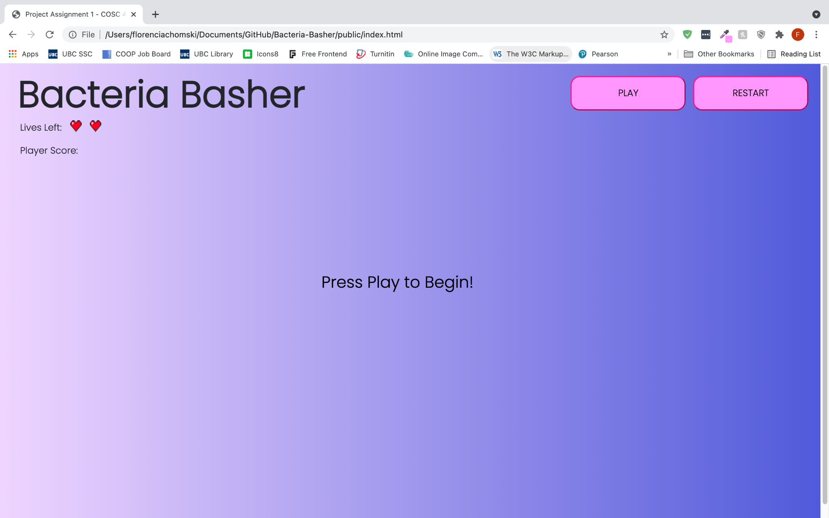

*The game does not begin until the player clicks on the ‘PLAY’ button in the top-right hand side of the screen. On the press of this button, the game disk is drawn and the bacteria begins growing along the circumference. As well, there is a restart button that when clicked, will reset the game including the game variables such as player lives, player score, and bacteria locations.*